**Leader Overview**



**Volume Overview**

**Navigate Hardship**

*Life is hard, even for believers. We all know it or discover it soon enough. Life tests our patience, our hope, and our sense of God’s presence. But we are not left hopeless in our challenges. God’s presence is more certain than even our hardships. Still, there are times in life that we need to be reminded that He is present. It’s in hardships that we learn to recognize it. We also learn to depend on God, to wait, and to look forward to His rescue.*

**Session Overview**

**Look Forward**

*In this* **Live** *session, preschoolers will discover that they can always trust God’s leading. Through the story of a father who traveled to see Jesus and beg Him to heal his son, preschoolers will explore the truth that they can always trust God’s Word and His instructions. Preschoolers will find out that it’s important to follow God even when our human eyes can’t see His answer yet.*

**Bible Lesson**

A Father’s Journey for His Son’s Healing

[John 4:43–54](https://ref.ly/logosref/Bible.Jn4.43-54)

**Faith Fact**

I can trust God to lead me.

**Faith Verse**

[Psalm 34:19](https://ref.ly/logosref/Bible.Ps34.19) (NLT)

The righteous person faces many troubles, but the Lord comes to the rescue each time.

**Preparing for the Session**

**Leader Preparation Time: 20–25 Minutes**

|  |
| --- |
| ***You Will Need***  ***Preservice Activities***  *• Toys*  *• Snacks for trail mix (mini pretzels, fish crackers, milk chocolate chips, colorful candies, etc.)*  *• Large serving bowls, one per snack food*  *• Small cups or bowls, one per kid*  *• Plastic spoons, one per kid per bowl*  *• Tongs or larger spoons, one per each large serving bowl*  ***Large Group***  *• Bible*  *• Worship songs (Song suggestions: “Boom” Lyric Video by Go Kids Worship; “For All My Days” Lyric Video by Gateway Kids Worship; “Jump” Lyric Video by Go Kids Music)*  *• For groups not using a phone or tablet only, add:*  *• Projector or TV*  *• Laptop*  *•* ***Faith Fact Sound*** *video (bell ringing)*  *•* ***Faith Fact Slide***  ***• Faith Verse Slide***  *•* ***Faith Verse Video***  *•* ***Bible Lesson Video A***  *•* ***Bible Lesson Video B***  ***Small Group***  *• Arm float used for swimming*  *•* ***Small Group Activity Page****, one per kid*  *• Pencils, one per kid*  *• Floor-safe tape*  *• Box to crawl through*  *• Ball*  *• Construction paper, one color per activity*  *• Chair*  *• String*  *• Scissors*  *• Straw*  *• Balloon, one per group*  *• Clothespin*  *To access session content and videos from a computer, visit:* [***BibleEngagementProject.com/downloads***](https://bibleengagementproject.com/downloads) |
| ***Getting Ready***  ***Preservice Activities***  *• Set out toys and snacks.*  *• Put each food in a large serving bowl with tongs or a serving spoon.*  *• Place the serving bowls around the meeting space.*  ***Large Group***  *• Download videos and slides if needed.*  *• Select worship song(s) and have them ready to play.*  ***Small Group***  *• Print copies of the* ***Small Group Activity Page****, one per kid*  *• Create five or more activity paths on the floor with the tape that kids can complete in any order. Ideas include: Balance line, lines to jump across, lines to kick a ball between, box to crawl through, zigzag line, etc.*  *• Place a different color of paper at the beginning of each activity. Optional: Add numbers to the papers if any of your kids are colorblind.*  *• Add a chair with a colored paper for kids to sit on to say the Faith Fact.*  • *Watch the video of how to make a balloon rocket:* [*https://www.youtube.com/watch?v=TfZsGy_q9zA*](https://www.youtube.com/watch?v=TfZsGy_q9zA)  *• Cut a piece of string about 10 to 15 feet long. Insert the string through a straw.*  *• Use three pieces of tape to attach the balloon to the string.*  *• Test this ahead of time to make sure your balloon is big enough and has enough air to make it down the string.*  ***First time leading* Live *for Preschool? Check out the*** [**Facilitator Guide**](https://0b769b0ed3569ef9d18b-f88d8272f61086866d50d048b43ef630.ssl.cf2.rackcdn.com/sites/biblengagementproject/Listen_Facilitator_Guide.pdf)**.** |

**Preservice Activities**

*See what’s needed at the beginning of the session.*

**Bible Story Warm-Up**

Have you ever had someone copy you? *(Group response)* What is one way they copied you? *(Allow responses.)* There are a lot of ways that we can copy someone. Let’s try it. I want you to copy whatever I do.

• *Do a series of actions and sounds for kids to repeat.*

Wow! You are really good at copying me! That was fun.

Which was your favorite action to follow?

What other thing were you hoping I would do?

Did you know that the person you are copying is really leading you?

One important thing to remember is to make sure that the person you are copying is a good leader. There are a lot of people in life who will try to get you to do that they want you to. But not everyone will lead you in a good way. Today, we’ll learn about the One we can always trust to lead us in the right direction.

• *Let kids lead actions again if time allows.*

**Snack**

**Trail Mix**

Today, we’ll hear about a father who went on a journey. A *journey* is a trip that can be short or long. If we’re going a journey, what are some things we need? *(Allow responses.)* Those are some great answers. Raise your hand if you think having a leader or guide would make a journey easier. (*Group response)* You’re right! Having a leader would make it so much easier.

Today, I’ll be your leader for snack time. If I’m your leader, what does that mean your job will be? *(Group response)* That’s right! Your job is to follow. Let’s begin our journey to get snack. When we’re done, we’ll have a great snack to eat.

• *Give each kid a small cup or bowl to make their own trail mix.*

• *Lead them around the room to the different bowls of trail mix ingredients.*

• *Serve the ingredients or allow kids to serve themselves.*

• *Lead them back to their seats.*

I hope you enjoyed our journey together. Now that our journey is over, you can eat your snack.

**Free Play**

*Any extra time can be spent playing with toys.*

**Transition**

*A few minutes before service begins have kids make their way to the large group area and sit in their designated areas.*

**Large Group**

**25 Minutes**

*See what’s needed at the beginning of the session.*

**Introduction**

Hi, friends! It’s so great to be here with you! I love learning more about who God is and what He tells us in the Bible. *(Hold up the Bible.)* We’ll have so much fun together. If you’re excited to be here, wave your hand at me! *(Group response)*

Today, we’ll learn about a father who walked a long way. Can you walk in place with me? *(Demonstrate.)* We’re walking. And we’re walking. I’m getting tired. Are you? *(Breathe hard and act exhausted.)* Okay, we can stop. The dad in our Bible story didn’t stop until he found Jesus.

**Faith Fact**

After he found Jesus and talked to Him, the father had to decide if he would trust Jesus’ leading or not. Guess what? That’s just like our Faith Fact today. **I can trust God to lead me.**

• *Show the* ***Faith Fact Slide.***

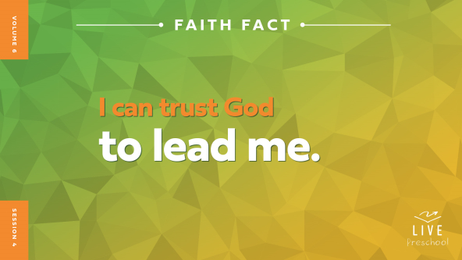

I hope you’re rested. Now, let’s run in place and act really excited while we say it. **I can trust God to lead me**. Now, let’s get our arms pumping while we run in place *(demonstrate)*. Say it one more time. **I can trust God to lead me**.

**Bible Time**

Oh, my goodness! Are you worn out yet? *(Group response)* I’ll have to work hard to keep up with all of you. I’m glad we have our Bible time next so I can rest. Our special friend, Lizzy, always has such good Bible stories for us. Let’s check in with her.

• *Play* ***Bible Lesson Video A****.*

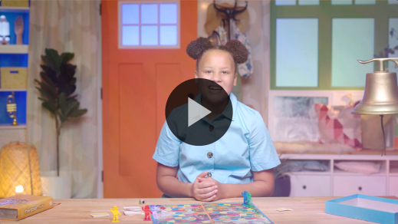

What an interesting clue! Nod your head if you’re glad Grandpa gave us a little time to think! *(Group response)* Let’s give God our praise and worship, and then we’ll come back to our Bible story in a little while.

**Worship**

I can hear your words when we worship. Who else hears your worship? *(Group response)* Yes! God hears every word you whisper and every song you sing. He sees every motion you do in praise to Him. Let’s take this opportunity to worship God and declare that He is good and worthy of our worship.

**Praise**

Who wants to thank God for leading us? Touch your walking feet down low. *(Group response)*

Are you glad you can always trust Him? Jump as high as you can. *(Group response)*

Who wants to follow God wherever He leads? Spin around in a circle one time. *(Group response)*

**Sing**

We can also worship God by singing. Wave your hand at me if you love to sing worship songs. *(Group response)*

• *Lead the kids in singing one or two songs. See song suggestions at the beginning of the session.*

**Prayer**

It’s so good to worship God with all of you. It’s so good for us to remember how amazing God is. He loves us so much. Let’s bow our heads and pray.

|  |
| --- |
| *Dear God, You created so many good things for us to explore and enjoy. We praise You for all that You are and all that You’ve done. Help us to become closer to You. Show us how to trust You to lead us. Amen.* |

**Bible Time cont’d**

• *Start* ***Bible Lesson Video B*** *and pause on the image of the two choices.*

It’s almost time for Grandpa and Lizzy to come back! We better decide what we think happens next in our story. Let’s put on our thinking caps *(demonstrate).* What do you think?

Did the sick boy’s dad believe Jesus’ words and go back home? *(Point to “walking man” graphic on screen)* Or did he not believe that Jesus could heal his son from far away and go away sad? *(Point to “red hand” graphic on screen.)*

If you think the father believed Jesus’ words, walk in place when I say, “Go.” If you think the dad didn’t think Jesus could heal his son, put one hand up like you’re telling me to stop. Ready? Go!

• *Pause while kids respond.*

Let’s find out if you’re right! Let’s go back to Lizzy and Grandpa.

• *Play* ***Bible Lesson Video B****.*

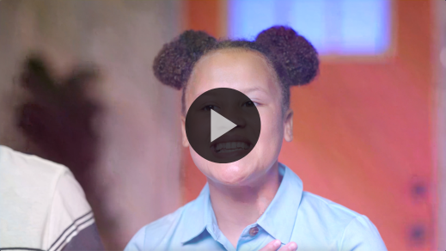

I don’t know who’s going to win that game between Lizzy and Grandpa, but I do know that we can trust God to lead us. That was a great Bible story!

**Response Time**

*Play a worship song quietly.*

Since we’ve heard from God’s Word, let’s respond to what we’ve learned. Can you crouch down and put your hands on your feet? *(Demonstrate and then have kids stand up again.)* We want these feet to always follow God wherever He leads, don’t we? *(Group response)* Let’s pray and tell God that.

• *Have the kids repeat phrases of the prayer after you.*

|  |
| --- |
| *Dear God, thank You for promising to always lead me. I want to follow You. I want to go where You want me to. I want to say the things You want me to say and do the things You want me to do. Amen.* |

**Faith Verse**

God is so pleased when we follow Him. Our Faith Verse is a great reminder that He is always ready to lead us on the right path. Let’s say our Faith Verse and do the actions together.

[Psalm 34:19](https://ref.ly/logosref/Bible.Ps34.19) (NLT)

The righteous person faces many troubles, but the Lord comes to the rescue each time.

• *Show the* ***Faith Verse Video****.*

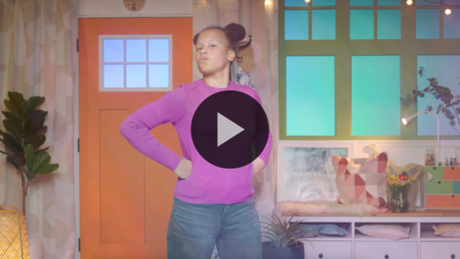

**Psalm** *(hands at waist, spread apart, palms up and out)*

**34:** *(hands together like a clap)*

**19** *(hands opened to “book”)*

**The righteous person** *(hands on hips with triumphant look on face)*

**faces many troubles,** *(fists up to chin with scared look on face)*

**but the Lord comes to the rescue** *(run in place)*

**each time.** *(jump once with each word)*

Wow! Great job, friends! That’s a Faith Verse we should always remember.

**Closing**

I’ve had so much fun with you today. Did you enjoy hearing our Bible story today? *(Group response)* I loved exploring how the sick boy’s father had to trust in Jesus’ leading as he walked home. And then the dad found out that his son was healed right when Jesus said he would be healed. That’s amazing!

• *Play the* ***Faith Fact Sound video*** *(bell ringing).*

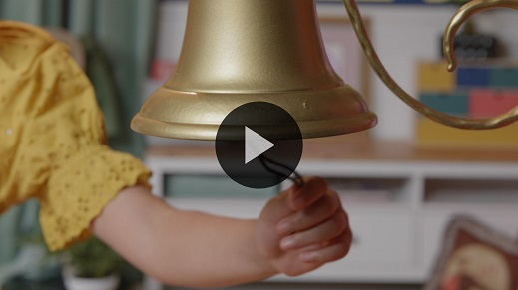

I know I can always trust God to lead me. How about you? *(Group response)* That sounds means we get to say our Faith Fact again. **I can trust God to lead me.**

• *Show the* ***Faith Fact Slide****.*



Let’s point to ourself when we say, “I,” and we’ll point up to heaven when we say, “God.” Are you ready? *(Group response)* Great! Let’s say our Faith Fact one last time. **I can trust God to lead me.**

**Dismissal to Small Groups**

Wonderful! We get to do something very fun now. It’s time to do some activities with our very special small groups.

• *Dismiss the kids by groups.*

|  |
| --- |
| ***Leader Tip:*** *This can be done by assigning color teams or by age groups. Note that some young preschoolers may not know their age. Using a colored sticker, jersey, or wristband will help separate the kids and help identify their small groups.* |

**Small Group**

**25 Minutes**

*See supplies and prep instructions at beginning of session or in each activity below.*

|  |
| --- |
| ***Leader Tip:*** *Small groups can alternate to each circle, or all groups can do each activity at the same time. If you choose to alternate, you will need at least one leader per circle.* |

**Circle 1**

**Group Connection**

**Getting to Float You**

|  |
| --- |
| ***You Will Need***  *• Arm float used for swimming*  *No prep is needed for this activity.* |

• *Hold up the arm float.*

Have you ever used one of these when you went swimming? *(Group response)* Why did you need to wear this? *(Allow responses.)* Putting one of these on each arm can help someone float or learn to swim. Arm floats keep kids safe. What might happen if they went into the water without these on their arms? *(Allow responses.)*

Without these floats, someone could be in a lot of trouble if they didn’t know how to swim They might even need to be rescued. Wait, that reminds me of our Faith Verse. Why don’t we say it together?

• *Have kids stand in a circle.*

• *Lead kids in saying the Faith Verse with actions.*

**Psalm** *(hands at waist, spread apart, palms up and out)*

**34:** *(hands together like a clap)*

**19** *(hands opened to “book”)*

**The righteous person** *(hands on hips with triumphant look on face)*

**faces many troubles,** *(fists up to chin with scared look on face)*

**but the Lord comes to the rescue** *(run in place)*

**each time.** *(jump once with each word)*

Let’s take this float and pass it around the circle. Each time someone gets the float, we’ll say another word of our Faith Verse. Let’s see if we can say the whole verse together as we pass the float.

• *Say each word of the verse together as you pass the float.*

This Bible verse helps us know that even people who love Jesus will face troubles. In our Bible story, a boy was sick, so his dad needed to go to Jesus. This time when we pass the float, tell the group one hard thing that kids face.

• *Make sure every kid is able to contribute. Be ready to help them come up with an idea if they get stuck.*

That was amazing! You all are so smart and mentioned many times when God can help us with hard things. Let’s say our Faith Verse together one more time.

[Psalm 34:19](https://ref.ly/logosref/Bible.Ps34.19) (NLT)

The righteous person faces many troubles, but the Lord comes to the rescue each time.

**Circle 2**

**Activity Page Time**

**Follow the Lead**

|  |
| --- |
| ***You Will Need***  *•* ***Small Group Activity Page****, one per kid*  *• Pencils, one per kid*  ***Getting Ready***  *• Print copies of the* ***Small Group Activity Page****, one per kid.* |

We learned in our Bible story that we can trust God to lead us. There are lots of ways that He can lead us: through His Word, by talking to us when we pray, and through other people. On the ***Activity Page***, you’ll help some people follow the path to God.

• *Hand out a copy of the* ***Small Group Activity Page*** *and a pencil to each kid.*

• *Allow time for kids to complete the activity.*

• *During the activity, interrupt and practice the Faith Fact:* **I can trust God to lead me.**

• *Play the* ***Faith Fact Sound*** *video. Review the Faith Fact even if you can’t play the sound.*



Wow! You all did a great job! Was everyone on our page a kid like you? *(Group response)* You’re right! One of them was a grown-up. Do you think grown-ups need to trust God to lead them? *(Group response)* We sure do! Remember how Jesus led the sick boy’s father in our Bible story and told him to go home. Jesus wants to lead everyone—young and old. No matter what is going on in our life, we can always trust God to lead us.

**Circle 3**

**Feet-to-Floor Game Time**

**This Way and That Way**

|  |
| --- |
| ***You Will Need***  *• Floor-safe tape*  *• Box to crawl through*  *• Ball*  *• Construction paper, one color per activity*  *• Chair*  ***Getting Ready***  *• Create five or more activity paths on the floor with the tape that kids can complete in any order. Ideas include: Balance line, lines to jump across, lines to kick a ball between, box to crawl through, zigzag line, etc.*  *• Place a different color of paper at the beginning of each activity. Optional: Add numbers to the papers if any of your kids are colorblind.*  *• Add a chair with a colored paper for kids to sit on to say the Faith Fact.* |

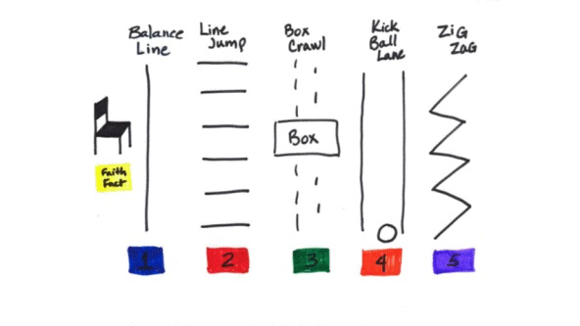

Who is ready to move around in a fun game? *(Group response)* Great! Our game will require balance, speed, and the ability to follow directions.

• *Demonstrate each activity while you give kids instructions about how to complete each activity.*

Our Faith Fact reminds us that God wants to lead us. Let’s practice saying it together. Ready? **I can trust God to lead me.** Amazing! Like the sick boy’s father in our Bible story, we may not know God’s directions when we first go to Him. His directions may surprise us! Let’s practice listening and following unexpected directions. When it’s your turn, I’ll tell you the order of the activities you need to do, based on the colored paper beside them. You’ll quickly do each activity, and then sit on the Faith Fact chair. After you’ve said the Faith Fact, you’ll jump up and go to the end of the line. Then the next person gets to go. Now, who’s ready to tackle these activities? (*Group response)*

• *Call out one or two instructions for each kid. After a kid completes their instructions, have them go to the Faith Fact chair. After they say the Faith Fact, they’ll go to the end of the line.*

You kids did great! I loved watching all of you following directions. Just like you trusted me to lead you in this game, you can trust God to lead you in life.

**Circle 4**

**Hands-On Learning**

**Zoom Balloon**

|  |
| --- |
| ***You Will Need***  *• String*  *• Scissors*  *• Straw*  *• Balloon, one per group*  *• Clothespin*  ***Getting Ready***  *• Watch the video of how to make a balloon rocket:* [*https://www.youtube.com/watch?v=TfZsGy_q9zA*](https://www.youtube.com/watch?v=TfZsGy_q9zA)  *• Cut a piece of string about 10 to 15 feet long. Insert the string through a straw.*  *• Use three pieces of tape to attach the balloon to the string.*  *• Test this ahead of time to make sure your balloon is big enough and has enough air to make it down the string.* |

Today we’ve talked about how we can trust God to lead us. When we try to do things on our own, we’re like this balloon.

• *Hold up the uninflated balloon.*

Do you think I can get this balloon to the other side of the room? *(Group response)* Let’s see. I could try and throw it.

• *Throw the balloon but be sure that it doesn’t make it across the room.*

Did it make it? *(Group response)* No, it sure didn’t. What if I blow it up?

• *Blow up balloon but don’t tie it.*

If I let it go, I think it might fly. Maybe that will get it across the room. Who wants me to let it go and find out? *(Group response)* Okay, let’s count it down. Three. Two. One. Go. *(Let balloon fly.)* That was crazy, but it didn’t make it across the room. Hmm. I don’t think a balloon can go across the room on its own.

Maybe our Faith Fact can help us. It says we need God to lead us. Maybe the balloon needs someone to lead it. Let’s see what happens if we try that. I need two volunteers.

• *Have two kids hold the ends of the string and pull it tight. Position them across the room from each other.*

Let’s see if our volunteers can lead the balloon from one person to the other across the room.

• *Move the straw all the way to one end of the string.*

• *Blow up the balloon. Twist it closed, and then pinch it with the clothespin.*

• *Use three strips of tape to attach the balloon to the straw on the string. Ensure that the “open” side of the balloon is toward the end so the balloon will propel down the string.*

Okay, do you think it will work? *(Group response)* Let’s find out. Here we go! *(Release the balloon.)* Whoa, that was amazing! It made it all the way across the room!

The balloon moved so much faster and further when it had something or someone leading it. The same is true for you and me. When we trust God and the plans that He has for our life, He will lead us in the right direction. It’s our job to listen and obey the things that God tells us to do. He always wants the very best for us!

**Dismissal**

• *Play the* ***Faith Fact Sound*** *video (bell ringing).*



• *Show the* ***Faith Fact Slide****.*



This was so much fun today! I can’t believe that our time is almost over. Learning with you is one of my favorite things to do. Before we go, can we say our Faith Fact together one last time? **I can trust God to lead me.** Amazing! I had a great time learning more about God’s Word with you. See you next time!

• *Send home the* ***Small Group******Activity Page*** *with each kid.*

• *Remind parents that there are* ***Family Devotions*** *available on the app to do with their kid.*

• *Tell everyone the date and time for the next session.*